**DEPARTMENT OF INFORMATION TECHNOLOGY**

**INSTITUTE OF ENGINEERING AND TECHNOLOGY , INDORE**

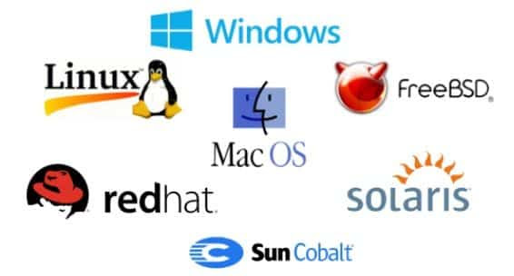

**LAB ASSIGNMENT OF OPERATING SYSTEM**

**SUBJECT CODE: 4ITRC2**

**LAB ASSIGNMENT - 03**

**NAME : ARUSH DIXIT**

**ROLLNO : 23I4118**

**CLASS : BE 2ND YEAR IT-B**1. To find Largest of Three Numbers

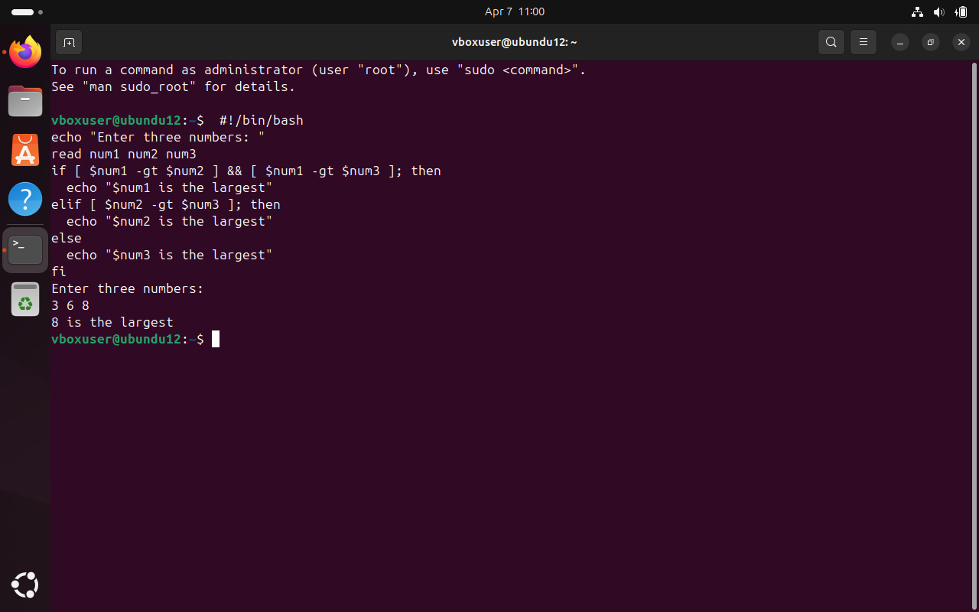

2. To find a year is leap year or not.

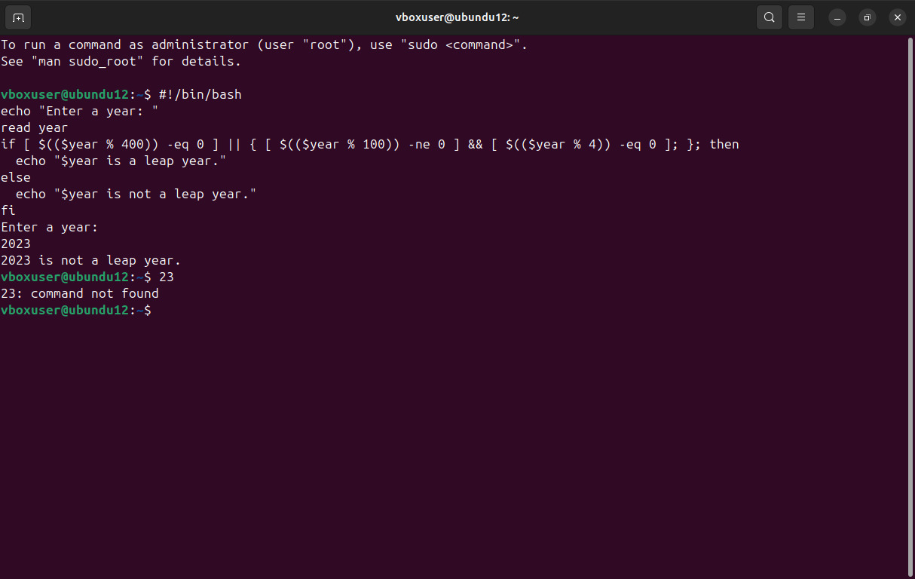

3. To input angles of a triangle and find out whether it is valid triangle or not

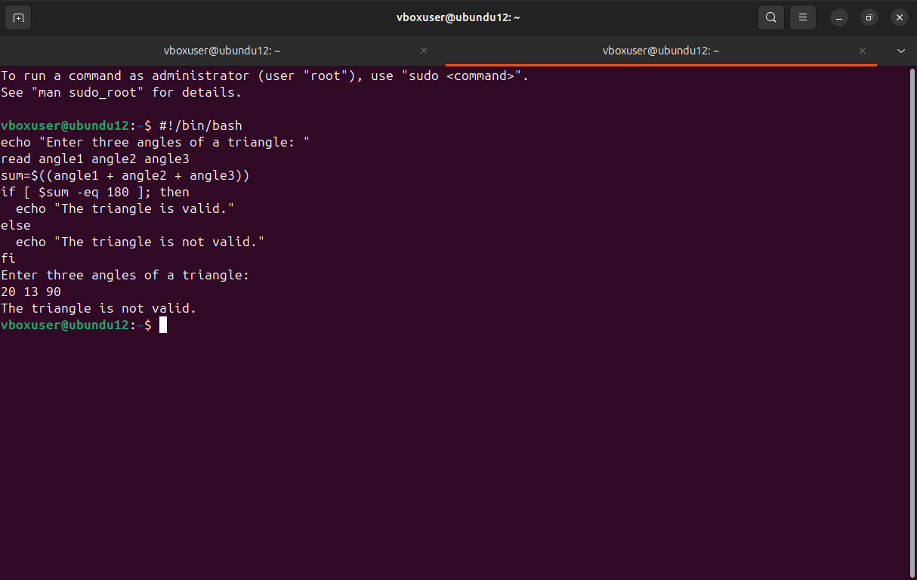

4. To check whether a character is alphabet, digit or special character.

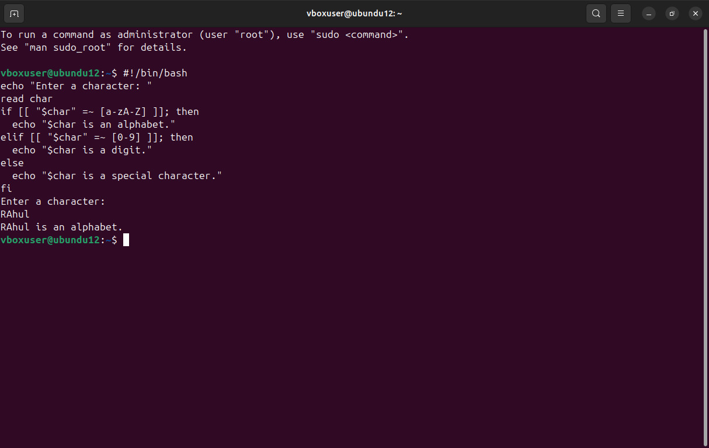

5. To calculate profit or loss

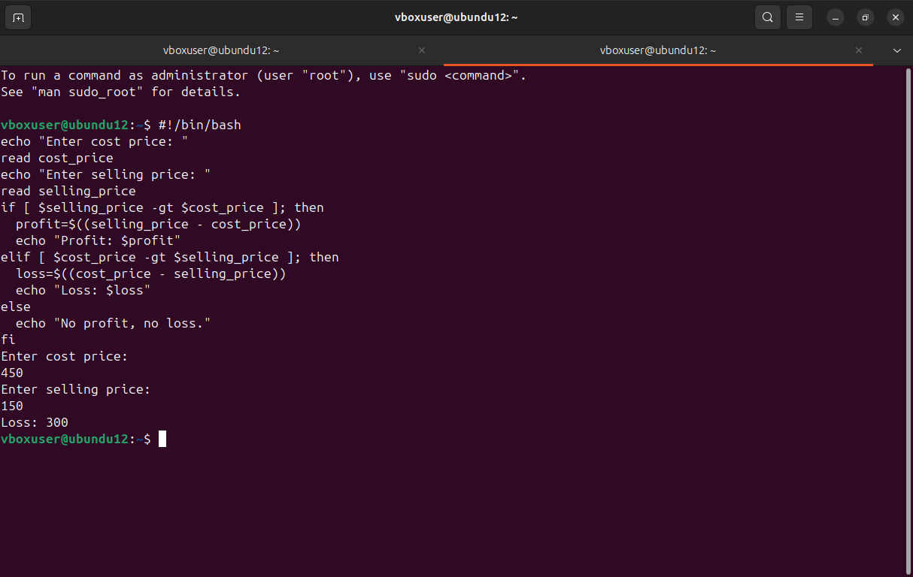

6. To print all even and odd number from 1 to 10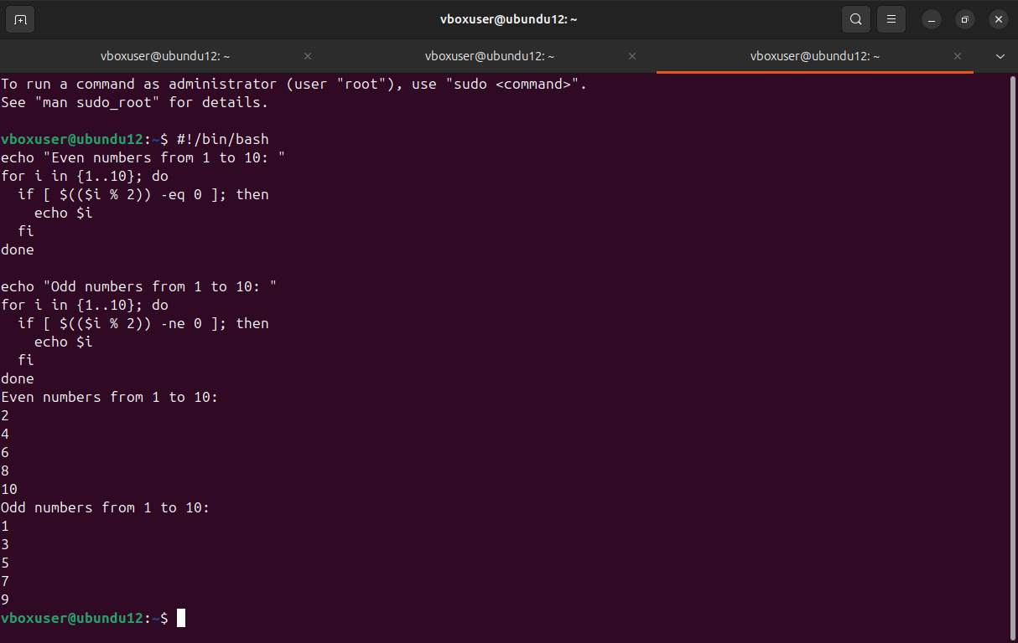

7. To print table of a given number

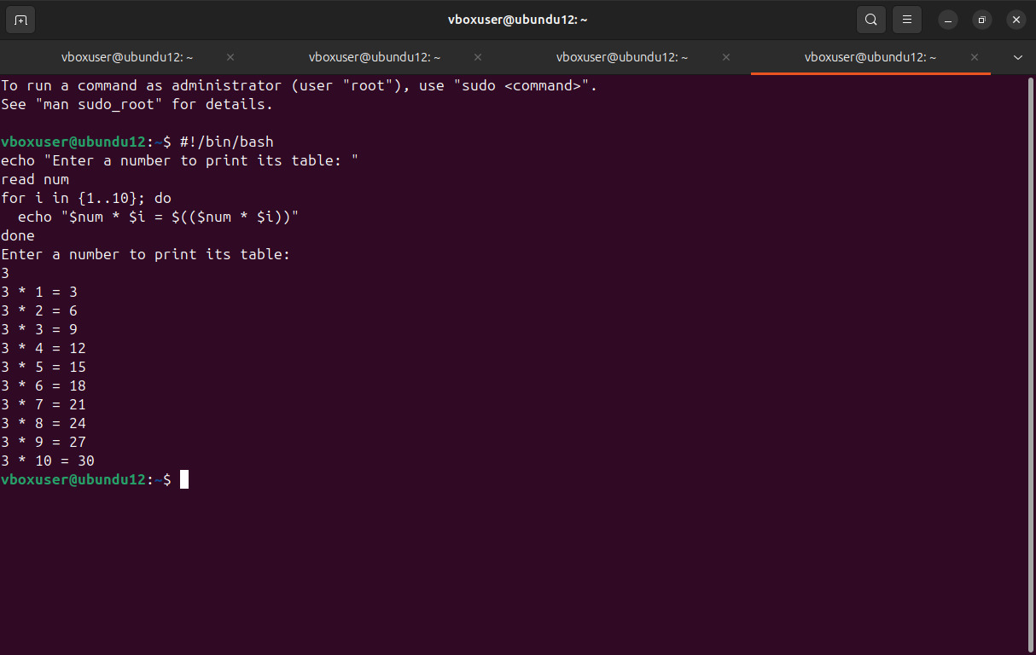

8. To find factorial of a given integer

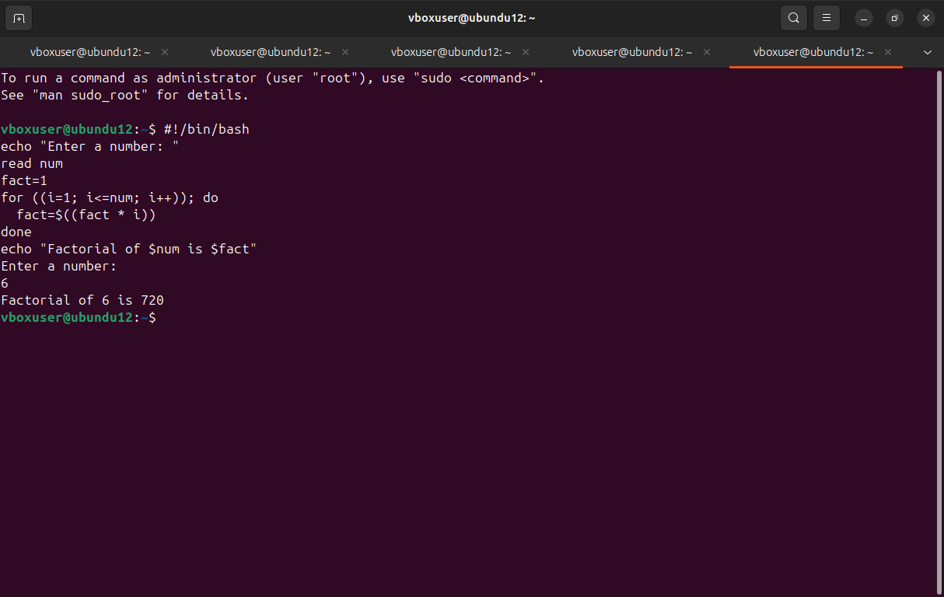

9. To print sum of all even numbers from 1 to 10.

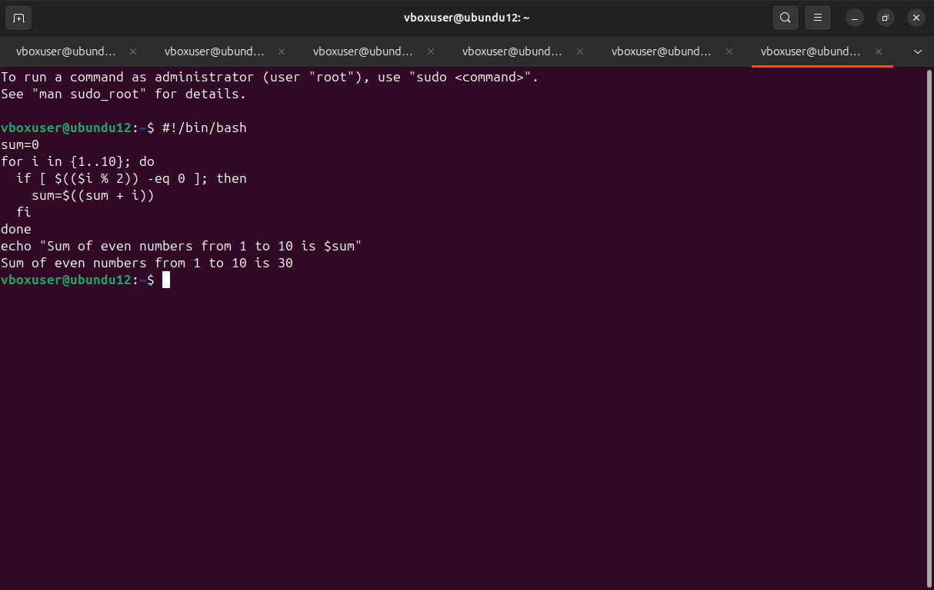

10. To print sum of digit of any number.

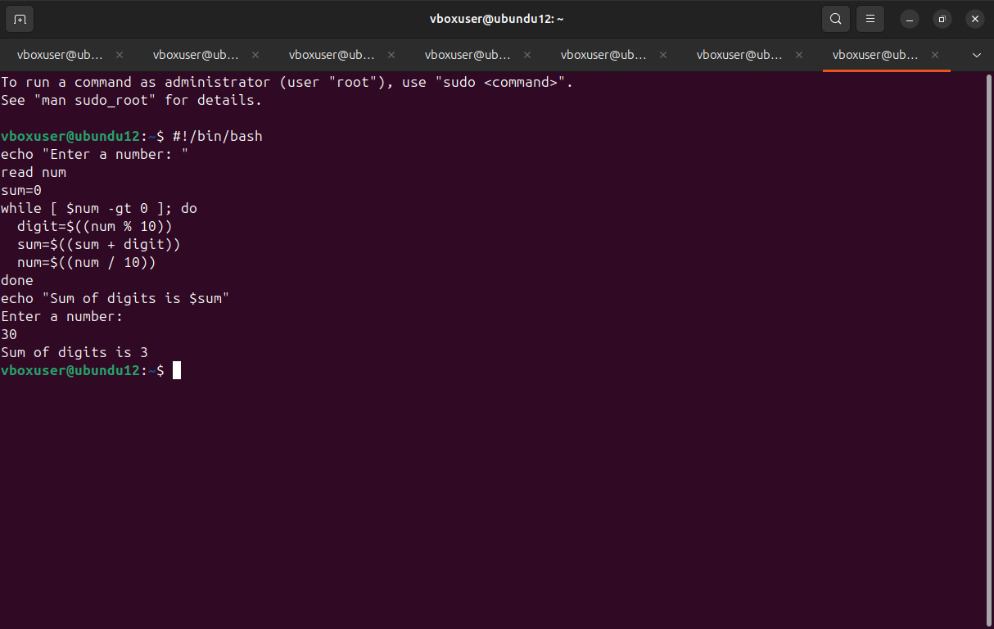

11. To make a basic calculator which performs addition, subtraction, Multiplication, division

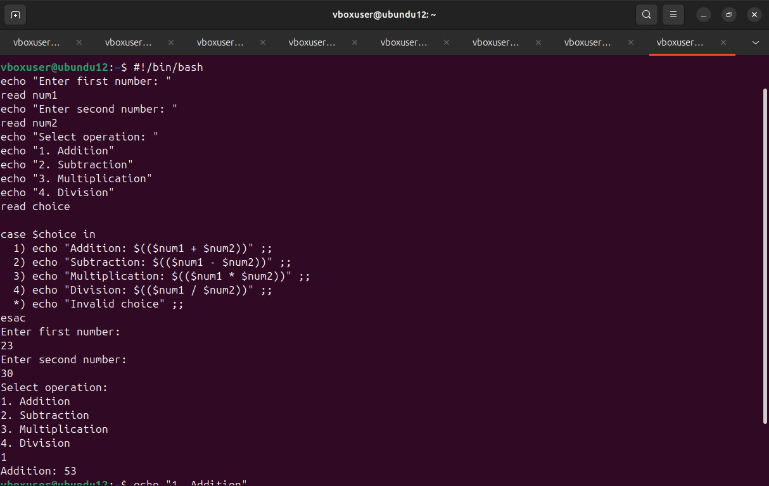

12. To print days of a week.

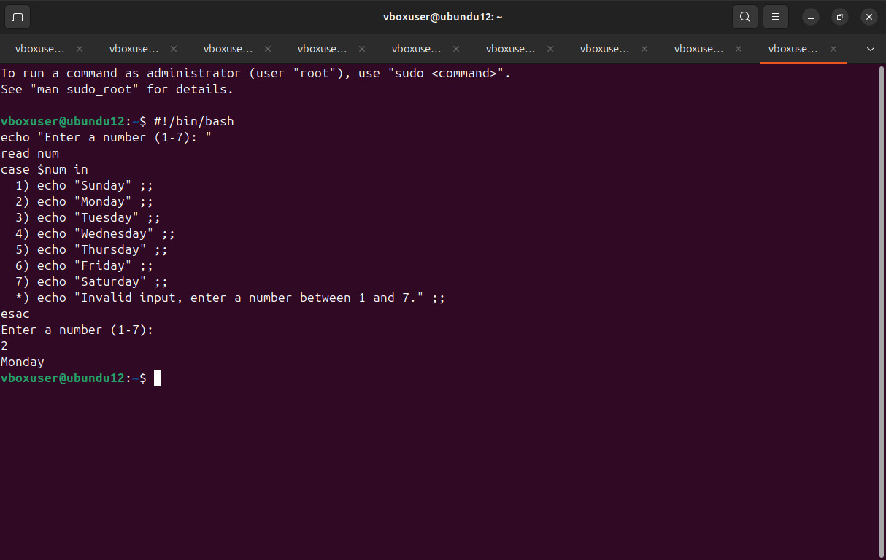

13. To print starting 4 months having 31 days.

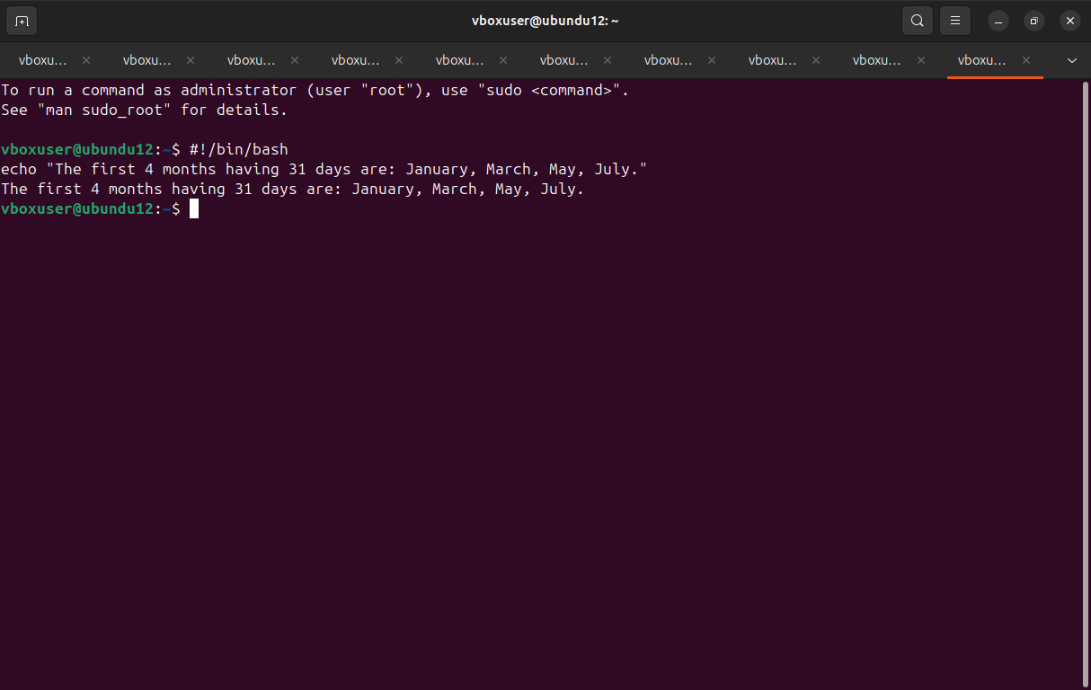

14. Using functions,

a. To find given number is Amstrong number or not

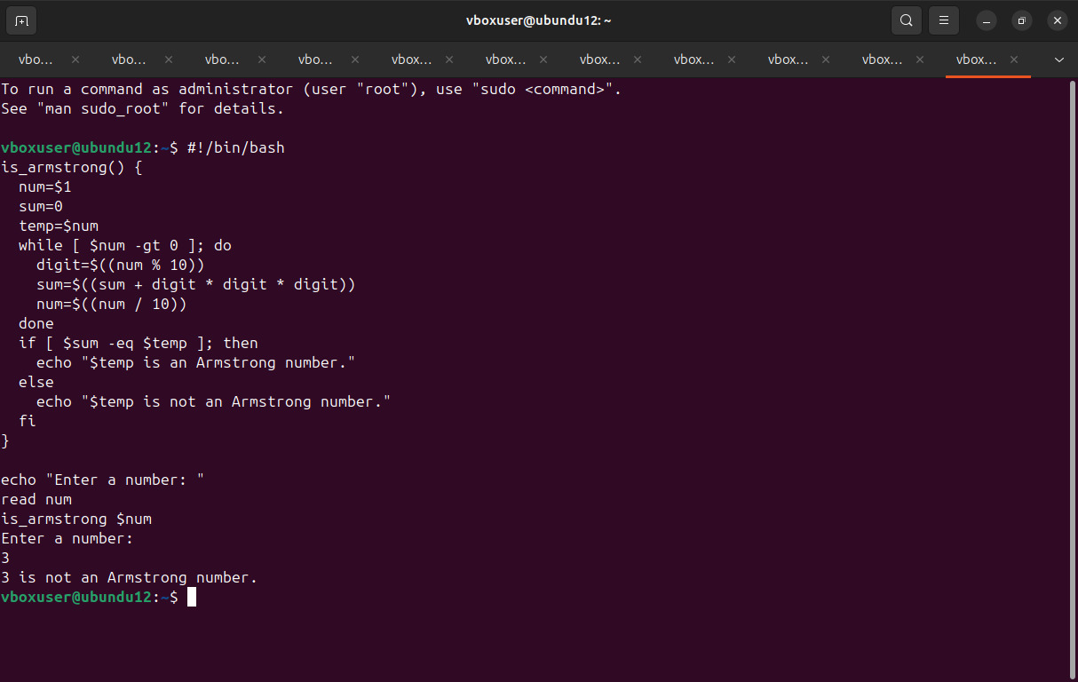

b. To find whether a number is palindrome or not

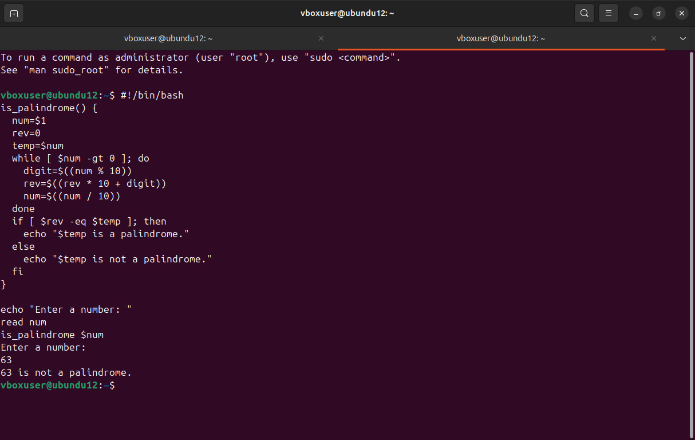

c. To print Fibonacci series upto n terms

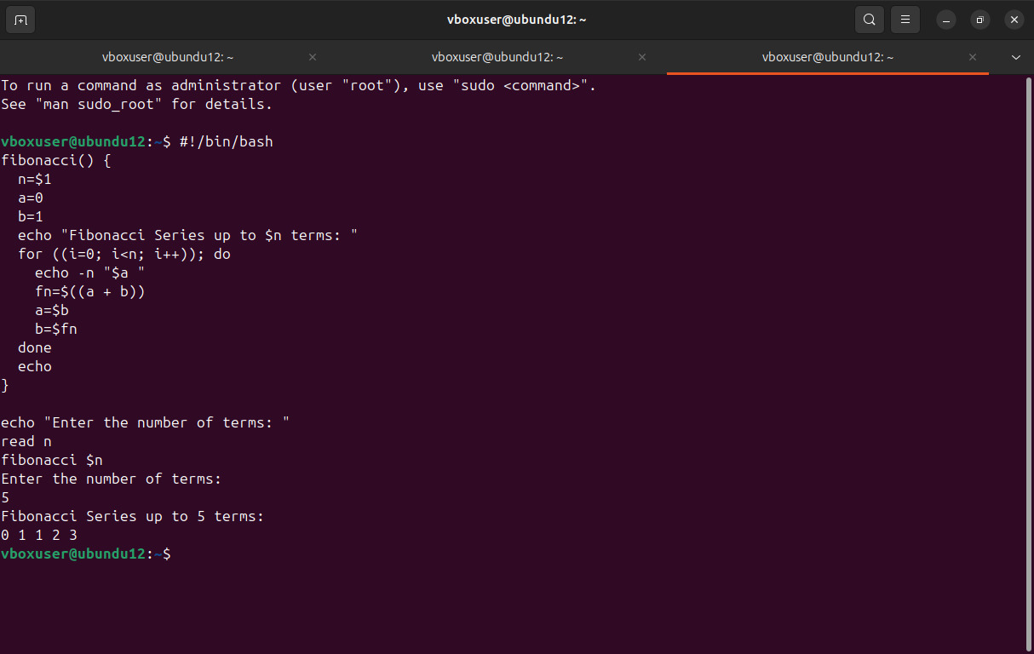

d. To find given number is prime or composite

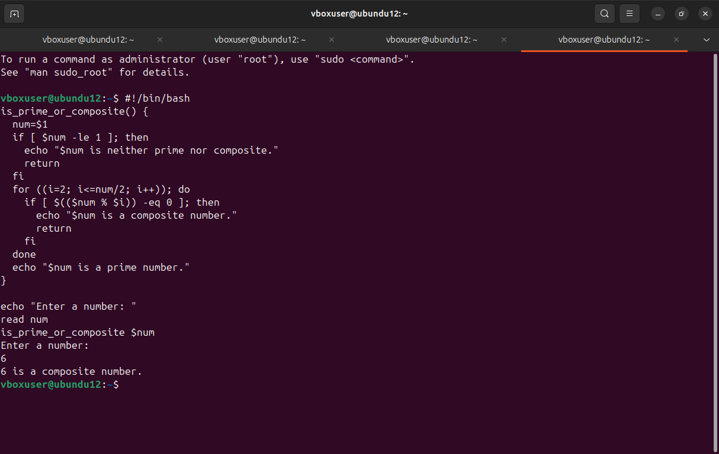

e. To convert a given decimal number to binary equivalent

